Demetrios Kechris ME570 HW1 Report

* 1. R(theta) plotted over 0 to 2pi  
      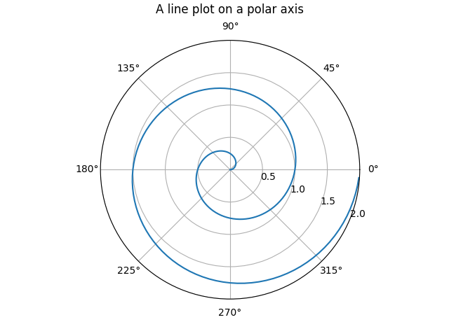

3.1) Show that ϕcircle(θ) ∈ S1 for all θ ∈ R, i.e., that (3) maps an angle θ to a point on the circle S1.  
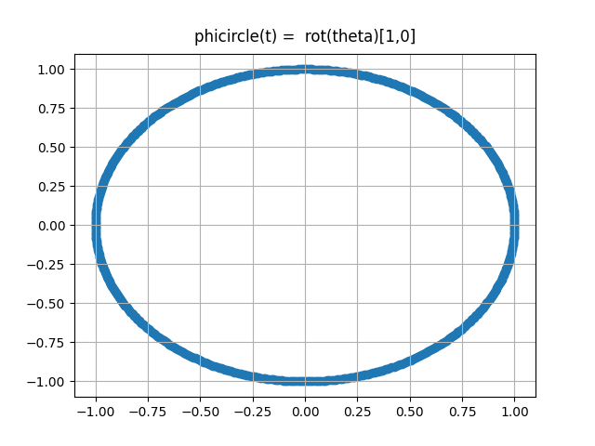

3.2) Run the function Torus.phi_test ( ) and include the result in your report.  
  
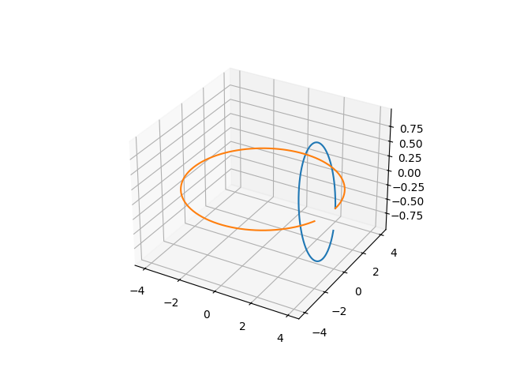

3.4) Include the figure produced by this function in your report  
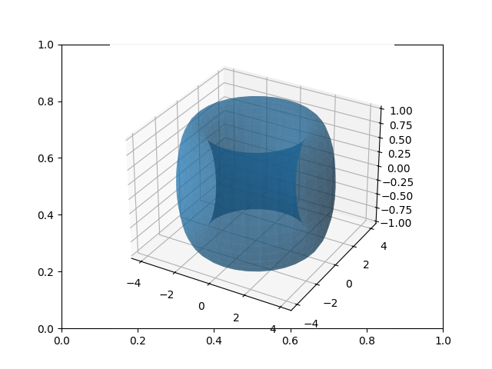

3.6 & 3.7) Include the output of the function provided in the previous question.  
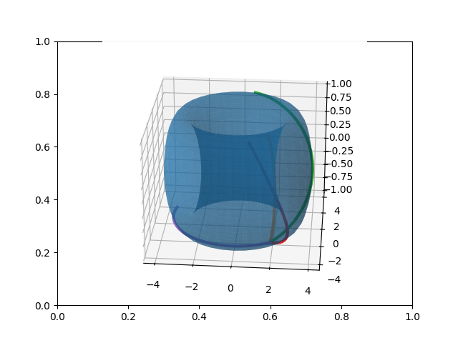

4.2) Include a figure with the output of the function twolink_plot_collision_test ( ). 